GASTROPOLIS: A CULIARY INTROSPECTIVE OF ILOILO CUISINE

An Undergraduate Thesis

Presented to the Faculty of the

College of Information and Communications Technology

West Visayas State University

La Paz, Iloilo City

In Partial Fulfillment

of the Requirements for the Degree

Bachelor of Science in Entertainment and Multimedia Computing

by

Nicole Anne D. Corral

Rizdy L. Huyatid

Henry R. Nopueto

Christian Jay O. Rentillo

Kenshin S. Supena

June 2025

Approval Sheet

GASTROPOLIS: A CULIARY INTROSPECTIVE OF ILOILO CUISINE

An Undergraduate Thesis for the Degree

Bachelor of Science in Entertainment and Multimedia Computing

By

Nicole Anne D. Corral

Rizdy L. Huyatid

Henry R. Nopueto

Christian Jay O. Rentillo

Kenshin S. Supeña

___Dr. Evan C. Sumido__

_ Ms. Christy G. Villano__­

Panel Panel

Mr. Mark Joseph J. Solidarios

_Ms. Janine P. Defante_

Panel  Adviser

Concurred:

Dr. Evan C. Sumido Dr. Ma. Beth S. Concepcion

Chair, EMC Division Dean

Acknowledgments

The researchers would like to express their deepest appreciation to the following persons, who in one way or another made this work possible:

Their parents and family, for the support throughout the process of conducting their study;

Mr. Mark Joseph Solidarios, research adviser, for the motivation and to finish the study on time;

Dr. Evan Sumido, for his overwhelming support, guidance, and providing his knowledge to the researchers of the study;

The co-researchers, who lend a hand throughout the study; and

Above all, the almighty God for granting the knowledge allowing the researchers to finish throughout the study.

Nicole Anne D. Corral

Rizdy L. Huyatid

Henry R. Nopueto

Christian Jay O. Rentillo

Kenshin S. Supeña

June 2025

N.A.D., Corral; R.L., Huyatid; H.R., Nopueto; K.S., Supeña; C.J.O., Rentillo; “Gastropolis: A Culinary Introspective of Iloilo Cuisine” Unpublished Undergraduate Thesis, Bachelor of Science in Entertainment and Multimedia Computing, West Visayas State University, Iloilo City, Philippines, June 2025

Abstract

This research study explores the culinary heritage of Iloilo City by developing “Gastropolis”, a 2D pixelated top-down role-playing adventure game that aims to promote both famous and traditional local cuisines. The game not only aims to entertain but also serves as an educational tool that introduces players to iconic Iloilo dishes and renowned landmarks that immerse players in the rich cultural landscape of the region, by sparking the interest and appreciation for Iloilo City as a City of Gastronomy awarded by UNESCO. To assess the game’s educational impact and user engagement, this study employed a mixed-method approach, combining survey and distribution with gameplay testing. Data collected from participants provided valuable insights into how effectively “Gastropolis” enhances players’ knowledge of Iloilo's unique food culture and traditions. Analysis of the findings revealed an overwhelmingly positive response, with users indicating increased curiosity, interest, and active engagement with the content presented in the game. These results demonstrated the potential of interactive digital platforms to serve as effective tools for cultural education and heritage preservation.

Table of Contents

Title Page...................................................i

Approval Sheet..............................................ii

Acknowledgments............................................iii

Abstract....................................................iv

Table of Contents...........................................vi

List of Figures.............................................ix

List of Tables...............................................x

List of Appendices..........................................xi

CHAPTER 1 INTRODUCTION TO THE STUDY..........................1

Background and Conceptual Framework of the Study........1

Objectives of the Study.................................3

Significance of the Study...............................4

Definition of Terms.....................................5

Delimitation of the Study..............................13

CHAPTER 2 REVIEW OF RELATED STUDIES.........................15

Video Game.............................................15

Video Game Development.................................15

Role-Playing Games.....................................16

Pixel Graphics.........................................17

Interactive Game.......................................17

Gamification...........................................18

Gastronomy.............................................18

Promoting Culture through Video Games..................19

Game-Based Learning....................................20

CHAPTER 3 RESEARCH DESIGN AND METHODOLOGY...................21

Description of the Proposed Study......................21

Methods and Proposed Enhancements......................22

Development Process....................................23

Components and Design..................................24

Game Architecture of the Proposed Game.................28

Game Flow..............................................31

Gameplay Machination...................................32

Game Development Life Cycle............................33

CHAPTER 4 RESULTS AND DISCUSSION............................35

Implementation.........................................35

Pre-Production.........................................36

Production.............................................39

Post-Production........................................45

Results Interpretation and Analysis....................52

CHAPTER 5 SUMMARY, CONCLUSIONS, AND RECOMMENDATIONS.........65

Summary of the Proposed Study Design and Implementation65

Summary of Findings....................................67

Conclusion.............................................69

Recommendation.........................................72

References..................................................73

Appendices..................................................86

List of Figures

1. Game Production Workflow.................................24

2. Game Architecture of the Proposed Game...................28

3. Game Flow Summary........................................31

4. Gameplay Machination.....................................32

5. Game Development Cycle...................................33

6.1. Game Script............................................37

6.2. MC Character Design....................................38

6.3. Assets made using AespriteFigure.......................38

6.4. Google stock photos used for map reference.............39

6.5. 2D Character Design made using Aesprite................41

6.6. 2D Map Environment Design made using Aesprite..........42

6.7. Soundtrack Composition using LMMS......................43

6.8. Game Programming inside RPG Maker MV...................44

6.9. Game Logo using Aseprite & Photoshop...................45

7.1. Main Menu when launching Gastropolis Game..............47

7.2. Interacting with NPC’s.................................48

7.3. Player choices and interaction.........................49

7.4. Player task and challenge..............................50

8. Demographic of Respondents...............................52

List of Tables

1. Variety of Respondent's Variation........................53

2. Age of the Respondents Percentage........................53

3. 5-Point Likert Scale scoring range.......................54

4. Evaluation of Results....................................55

5. Results of Flow / Immersion..............................56

6. Results of the Positive Effects..........................57

7. Results of Negative Effect...............................58

8. Results of Difficulties Encountered......................59

9. Results of Immersive Cultural and Food Experience........60

10. Results of Cultural Food and Storytelling Connection....61

11. Results of Musical and Audio Resonance..................63

12. Results of Overall Post-Game Sentiment..................64

List of Appendices

A. Letter to the Adviser....................................87

B. Letter to the English Editor.............................88

C. Letter to the Technical Editor...........................89

D. Letter to the Format Editor..............................90

E. Certification for Bookbinding............................91

F. Source code..............................................92

G. Disclaimer...............................................96

CHAPTER 1 INTRODUCTION OF THE STUDY

Background of the Study and Theoretical Framework

Video games are a popular form of entertainment that promotes social interaction and enhances learning capabilities. They allow people of all ages to learn, grow, and express themselves in immersive worlds, allowing them to adapt and build skills at their own pace [1]. Video games are interactive media that blend storytelling, visuals, and music to create an immersive experience for players. Unlike movies or books, video games allow active participation, creating a sense of presence within the game world, and enhancing the player's overall experience [2].

Iloilo is a city in the Western Visayas region of the Philippines and is renowned for its diverse cuisine influenced by Chinese, Malay, and Spanish cultures. It has earned the distinction in the Philippines for its creative cities of gastronomy by the United Nations Educational, Scientific, and Cultural Organization (UNESCO) [3].

Iloilo City captivates people, not only with its food, but also with its diverse backgrounds from different cultures. While recognized by UNESCO, there are many people, including locals, who have yet to discover it within the city’s borders and are still waiting to be explored [4].

In the digital age, video games have become more than just a form of entertainment. They have emerged as a powerful tool for cultural preservation, allowing players to explore and experience diverse cultures worldwide. Gaming bridges the gap between technology and cultural preservation through immersive gameplay and stunning visuals, making it an invaluable medium for educating and engaging individuals. [5].

The researcher’s approach to promoting Iloilo City's delicious cuisine and history involves using video games to showcase local foods and cultural identity. This strategy, not only helps sustain traditional practices, but also promotes economic development, cultural heritage preservation, and a sense of community. The recipes and processes featured in the game will reflect the authentic and signature dishes of Iloilo City.

Objectives of the Study

The researchers aimed to design and develop a game that advocates Iloilo City, which UNESCO has recognized as the City of Gastronomy.

Specifically, it aims to:

1. Develop a role-playing-exploration game with a narrative that is centered around the well-known dishes of Iloilo City;

2. Design a top-down open-world game, with the layout taking inspiration from Iloilo City’s architectural structures;

3. Create pixelated game assets and 8-bit sound to implement within the game; and

4. Evaluate the game by using “The Game Experience Questionnaire” adapted from Eindhoven University Technology, Department of Industrial Design and Human-Computer Interaction.

Significance of the Study

The study would benefit the following:

For the Gamers, the outcome of the study would enable them to learn the culture and history of the Philippines and expose the food of Iloilo City.

For the Video Game Community, the result of the study would enable people to see video games as a new form of medium for learning experience and promote cultural understanding of one’s ethnic background.

For Iloilo City, the outcome of the study would help promote Iloilo City’s cuisines and bring out cultural representation through video games that will support and motivate people about Filipino culture.

For food vloggers/social media influencers, the result of the study will make promoting/advertising cuisines in a more unique and fun way.

For Researchers, the outcome of this study would benefit future researchers who would use this study as a basis and guide for conducting their research study.

Definition of Terms

For better understanding, the following terms were defined conceptually and operationally:

2D video games. 2D games are flat, sprite-based experiences that only allow one to move up, down, left, and or right across the screen [6].

In this study, it refers to the type of game that will be used.

Aseprite.Aseprite, a popular tool used for creating and editing pixel art, is a program that allows game developers and animators to create sprites and related pixel art for their projects [7].

In this study, it refers to the program used to make the Character Sprites, Assets, and Background Design of the game.

Assets. Game assets are any individual element that makes up a video game. This can include artwork, 3D models, the user interface (UI), animation, special effects, music, voiceovers, and even scripting for things like physics [8].

In this study, it refers to the objects that are required for building a game.

Cuisine.Cuisine is the cooking process of preparation of traditional or popular dishes. Cuisine determines on what foods are available to cook and regulates the delicacies and religious foods [9].

In this study, it refers to the foods that are implemented within the game and its mechanics.

Culture. Culture refers to the cumulative knowledge and beliefs, values, and meanings acquired by a group of people of generations [10].

In this study, it refers to the cultural impact of food and history that shaped one’s culture.

Game Design. Game design sits under the broader field of video game development and refers to the use of creativity and design to develop a game for entertainment or educational purposes. It involves creating compelling stories, characters, goals, rules, and challenges that drive interactions with other characters, users, or objects [11].

In this study, it refers to the structure of the game and the design of the game’s layout.

Gameplay. Gameplay is essential for overall game quality and player satisfaction [12].

In this study, it refers to the actions that the player can do within the game and what possible mechanics will be introduced.

Games.A game is a structured experience consisting of a goal, rules, a feedback system, and voluntary participation, all built around an interconnected system [13].

In this study, it refers to the problems that the player will face in the game and must find possible ways to solve the problem.

Genre. Video game genres are categories of games that have similar gameplay and gameplay mechanics [14].

In this study, it refers to the type of category that will be used for the game.

Gastronomy.Gastronomy is the selection, preparation, presentation, and participation of culinary, and aspects of food. Most societies seek to differentiate food preparations, methods, presentation, and participation for aesthetic purposes [15].

In this study, it refers to the recognition of Iloilo’s achievement of being the city of gastronomy for the game.

Levels. Levels is a term that means a stage, episode, or mission that the player must complete on the way to complete the entirety of the game [16].

In this study, it refers to the different areas that will be introduced in the game.

LMMS (Linux Multimedia Studio). This digital audio workstation application program allows music to be produced by arranging samples. Synthesizing sounds, entering notes, and combining the features of trackers and sequencers. It is free and an open-source software [17].

This study refers to the creation of the music for the game’s sound cues and background sounds.

Map.Map consists of stages that are connected to other stages either, one or more, that allow the player to move anywhere in the area [18].

In this study, it refers to the different areas of the game from different locations.

Mechanics.Game mechanics are the rules, elements, and processes that make up a game. In essence, they define how the game works and what determines success or failure in the game. Game mechanics include player objectives and rewards, character interactions, level design, resource management systems, and more [19].

In this study, it refers to what action the player can do within the game.

Objectives. Objectives refer to the game’s main task to complete to progress the game [20].

In this study, it refers to the task that the player will do in the game.

Pixel art. Pixel art is a form of digital art wherein images are created and edited at the pixel level using graphics editing software.

In this study, it refers to the art style and direction that will be used in the game [21].

Prototype. Prototyping is the creation of a first, unfinished, low-fi version of one’s game or gamification that one can play with others to identify its merits and short comings and make improvements early in the process [22].

In this study, it refers to the early production of that game that will test the game’s feasibility and design.

Photoshop. This is an image creation, graphic design, and photo editing software developed by Adobe. The software provides many image editing features for pixel-based images, raster graphics, and vector graphics [23].

In this study, it refers to the creation of the game’s logo and images, as well as the editing of images that are used for the game.

Puzzle. a problem that may take many forms, including games and toys, and is solved through knowledge, ingenuity, or other skills. The solver of the puzzle must arrive at the correct answer, or answers, by thinking or putting pieces together in a logical way [24].

In this study, it refers to the challenges that the player must face and solve in order to proceed within the game’s story and discover items for the player to use.

RPG Maker. is a software platform that allows users to create role-playing video games without requiring extensive programming knowledge [25].

In this study, it refers to the engine that will be used in creating the game itself as well as the mechanics.

Quests. Quests are tasks, which players can accomplish in order to get further in the game and receive some kind of a reward [26].

In this study, it refers to the game’s content that is used for the game.

Role-playing game. A role-playing game (RPG) is a game in which each participant assumes the role of a character that can interact within the game's imaginary world [27].

In this study, it refers to the game’s genre that is used in the game.

Tilemap. Tilemap is a system that stores and handles the assets in creating the game’s 2D levels [28].

In this study, it refers to the different map designs and environments that are used in the game.

Top-down. Top-down perspective video games are video games where the perspective the player sees it from above, looking down, also referred to as the birds-eye view or helicopter view [29].

In this study, it refers to the type of game genre that the game will be used.

User Interface. UI refers to the graphical elements, controls, and menus that enable players to navigate, interact, and make decisions within the game environment [30].

In this study, it refers to the interface design that is used in the game.

Video games. Digitally based games typically played on personal computers or dedicated gaming devices, such as game consoles or handheld game devices [31].

In this study, it refers to serve as the primary medium for research and data collection.

Delimitation of the Study

This research study focused on creating a top-down 2D game, incorporating well-known foods of Iloilo City. Due to time, budget, and technical constraints, the game was not intended for full commercial release, having only three levels with few characters. The game was only released as an alpha version with a 2-4 hour playtime, including introductions, cutscenes, and credits, and followed an aspiring chef on a culinary quest.

The researchers used open-source and affordable software due to having limited performance hardware and performance issues that restricted the complexity and sophistication of the game. The researchers utilized Aseprite as their main application for creating character designs, environments, and other various assets and also used RPG Maker MV to create the game’s mechanics and structure. Some RPGMAKER assets were used as placeholders for certain places and items in the game. The scale of the game does not only focus in Iloilo City, but it covers different areas of the Philippines as a reference for the different levels of the game. Due to the limitations and functions of the RPG Maker engine, modifying or adding features to the game is difficult and restrictive. Implementing additional modifications is also constrained by the availability of plug-ins and the technical limitations of the game platform.

The testing was conducted on a limited number of participants, which may not have fully represented the diverse range of potential users. The primary goal was to demonstrate the learning outcomes and theoretical understanding, rather than creating a fully polished commercial product.

CHAPTER 2 REVIEW OF RELATED STUDIES

Review of Existing and Related Studies

*Video Game*

Video games, which primarily target male audiences, have become increasingly popular over the past decade. One study reported that the sales of video games have exceeded those of movies. As video games have become more popular and more realistic, so has the need to assess the content and the impact of these images on their male audience [32].

Video gameplay affects the individual and culture in a multitude of facets. Evidence is presented to suggest there are many positive effects of video gaming on well-being and less evidence to support the ideology that video games lead to heightened levels of aggression in adolescents [33].

*Video Game Development*

Video game development is the development of a project in detail that is almost impossible to plan accurately due to its large scale and continuous ideation and refinement of the

game. In process of creating a game, it involves critical decision-making, creative autonomy, and informal communication, which designs the creation of the game’s environment and maintains creativity and openness to product changes. Testing, design, and ideation are not only exclusive to game development, these are also applied to software and system development. Video game development is uniquely approached, for its functionality, effectivity, creativity, and ideation that give the game its distinct and characteristic [34].

*Role Playing Games*

RPGs seek to immerse the player in a character within a specific imaginary world, usually based to some degree on reality. RPGs can transmit cultural heritage, but the breadth and depth of engagement with culture depend on the game’s focus [35].

Further separating RPGs from other educational games is the narrative and mechanical emphasis of character development within a story. As the player explores and engages with the

game world, his choices move the narrative forward in one or more ways. As the game progresses, the player’s character

Develops narratively as well as mechanically, improving in-game skills and resulting in more influence and power over the game world [36].

In other RPGs, worldbuilding is a top-down process. A designer or group of designers creates the world from high concepts to detailed settings and non-player characters. Storylines, plots, and possible sequences of events may be more or less rigidly pre-scripted. While every game is a co-creation between player and designer, some games are specifically designed to balance their world-building aspects between players and designers [37].

*Pixel Graphics*

Pixel art was a popular technique used in video games starting from the 1970s until about the 1990s. At the time, graphic engines were restricted to a relatively small screen resolution and a color palette of only 256 colors. As a result, most if not all games in the 8-bit era came in a “pixelated” style simply known as pixel art. Pixel art plays a major part in defining stylized game graphics, and despite the advanced technology today, the art style is still seen in some modern indie games [38].

*Interactive Game*

Interactive games can be extremely demanding, often requiring deep levels of attention, managing more than one cognitive task at a time, or making quick responses. Players actively participate in a game by applying knowledge, devising strategies, making decisions, using skills, and reviewing the outcomes. The demands of a game engage players in what has been called “productive play”, the learning and accomplishment that can occur when playful activities lead, for instance, building virtual worlds, manipulating situations, or solving problems [39].

*Gamification*

Gamification is used for game design techniques, game thinking, and game mechanics to enhance non-game contexts. Gamification applies non-gaming applications and processes, for people to adapt or influence them. Gamification makes technology more engaging and encourages players to show mastery and autonomy when solving problems. Gamification can encourage people to perform unique tasks that would seem menial and boring to people [40].

*Gastronomy*

The City of Iloilo has been named a UNESCO City of Gastronomy in the latest UNESCO Creative Cities Network (UCCN) for 2023. The list was revealed on World Cities Day, adding 55 cities covering the seven creative fields of crafts and folk art, design, film, gastronomy, literature, media arts, and music. So far, only two other cities in the Philippines have become part of this creative network – Baguio for Crafts and Folk Arts in 2017; and Cebu for Design in 2019. Iloilo is the first Philippine city to be represented under Gastronomy *[41].*

Benefiting from a gastronomic element in the marketing of destinations has gradually increased in recent years. Considering local factors benefiting from the city's food cultivated in the marketing of destinations to attract tourists to the city, to provide branding and develop the economy of the city as a result. Gastronomic culture is also a destination that is not the only destination for dining diversity; people's lives, history traditions, and values [42].

*Promoting culture through video games*

Relating video games to culture implies understanding that both elements interact with each other because the video game as a medium allows for the reproduction, assimilation, transmission, and creation of culture [43].

Game design allows for the authentic representation of cultures, making it a powerful tool for preserving cultural heritage. Through historical accuracy, language preservation, and the inclusion of collectibles and artifacts, game design enables players to engage with and learn about various cultures [44].

*Game-based Learning*

Game-based learning incorporates game characteristics and principles into learning activities. Learning activities inspire student engagement and enthusiasm to learn. Points systems, badges, leaderboards, discussion boards, quizzes, and classroom response systems are all components of game-based learning [45].

CHAPTER 3 RESEARCH DESIGN AND METHODOLOGY

Description of the Proposed Study

The research study entitled “Gastropolis: A Culinary Introspective of Iloilo Cuisine” focused on developing a game that reflected Iloilo City’s achievement of being recognized by UNESCO as a City of Gastronomy. A game was created and written by the researchers and published by the proponents. The researchers utilized the RPG Maker engine to create the base game with three distinct areas signifying the different archipelago structures of the Philippines. Aseprite was used to develop character models, character sheets, environment tile maps, and environment objects implemented in RPG Maker. LMMS was employed to create the overall sound design. Photoshop was used to create the concept designs of the characters, as well as the game’s poster, icons, and assets.

The study also conducted a comprehensive testing phase with participants aged 12 and older, focusing on high school and college students. This demographic was selected due to their high engagement with gaming culture and their potential to provide valuable insights into game mechanics, storyline appeal, and cultural resonance with Iloilo City's gastronomic themes. Participants were invited to playtest the game and provide feedback on gameplay elements, cultural representation, and the educational aspects related to Iloilo's culinary heritage. Their responses were gathered through surveys and feedback sessions, allowing the researchers to refine the game based on user experience and to ensure it met both educational and entertainment objectives.

Methods and Proposed Enhancements

The creation of games as a tool for preserving the culture gives an entertaining approach to cultural heritage conservation. Younger generations may become enthusiastic and interested in local power spots and the city's culinary cuisines, which can also offer an immersive and engaging educational experience. Through this study, it is possible to bridge the gap between the old oral transmission of advertising cities' culture and online newsletters in the modern digital age, while offering a new platform for distributing and preserving intangible cultural heritage.

Development Process

The development process is something that every game developer has to follow if they want to create a good game. This process is iterative, which means that some features could sound good when written in papers, but then when created are not working properly or they are not as good as expected. Being iterative is good, this means that the developers are always trying to do their best fixing or updating the initial plans to create a better game.

The development process and its iteration during the production phase are shown in the following figure:

Components and Design

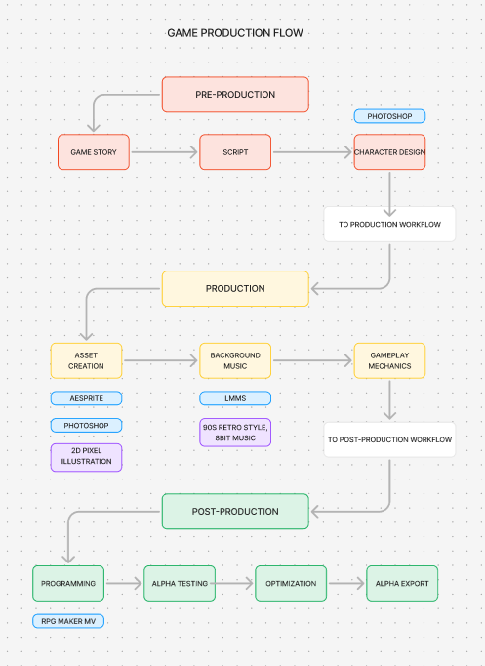

**Figure 1.** Game Production Workflow

Figure 1 shows the development process followed the specified Three-phase game production framework: Pre-production, Production, and Post-Production. However, each stage was further broken down into 6 distinct phases for more in-depth explanation to promote a more thorough understanding.

**Phase 1: Planning**

The game's general vision and objectives, as well as its mechanics, features, and cultural elements, were all defined in the first stage of development.

**Phase 2: Pre-production**

The second stage entailed creating the timetable, collecting data, and outlining each team member's responsibilities.

1. Document analysis - This method was used to collect data from various sources, including books, journal articles, and other publications related to the Iloilo the City of Gastronomy
2. Observation: The researchers collected data for the game's design, and photographed the town and its surrounding area then, they made notes of the important sites and landmarks connected to the City’s Culture.
3. When the researchers were done collecting the data, the game’s story was crafted, and its gameplay mechanics were structured using RPG Maker MV as the game engine throughout the entire production process. This phase also included prototyping characters, environments, and other elements by utilizing Aseprite and Photoshop.

**Phase 3: Production**

This was where the production process took place. For the map creation, the researchers utilized RPG Maker MV to create the game’s map. Each map of the game had three different levels, each unique from the others. After building the game’s map and different levels, the researchers began creating the game’s mechanics that would serve the game’s interactivity with the environment. Following that, the prototyping phase involved the researchers prototyping the game’s mechanics and interactivity within the game itself. During the prototyping phase, the researchers also looked out for potential bugs to prevent any problems from occurring.

**Phase 4: Post Production/Testing**

The post-production stage was the final stage of the game production process. For alpha testing, the researchers had to test the game’s structure and mechanics. Once the alpha phase is completed, the next phase is the testing phase, where the game will be distributed among limited participants and they will be asked for feedback on the game and recommendations.

During the testing phase, the researchers proceeded to bug-fixing, where they found and addressed any possible bugs within the game that were not spotted during its development. After the bug-fixing phase, the researchers moved on to the polishing stage, during which they refined the game to make it more appealing to users and conducted a final check. The export was the final stage of the game production workflow, where the game was completed in its entirety and exported for playability.

**Phase 5: Launch**

It is time to launch the game. This included putting the game's finishing touches and packaging it for release. This stage comprised distributing the game to the study's intended audience.

**Phase 6: Evaluation**

Evaluation is conducted to evaluate of how well the game accomplished its aims and objectives. In this phase, the researchers looked into the player comments to determine whether the game successfully preserved the culture through the game creation for which it was designed. The study was evaluated using the game experience questionnaire, based on the modular structure of the Game Experience Questionnaire

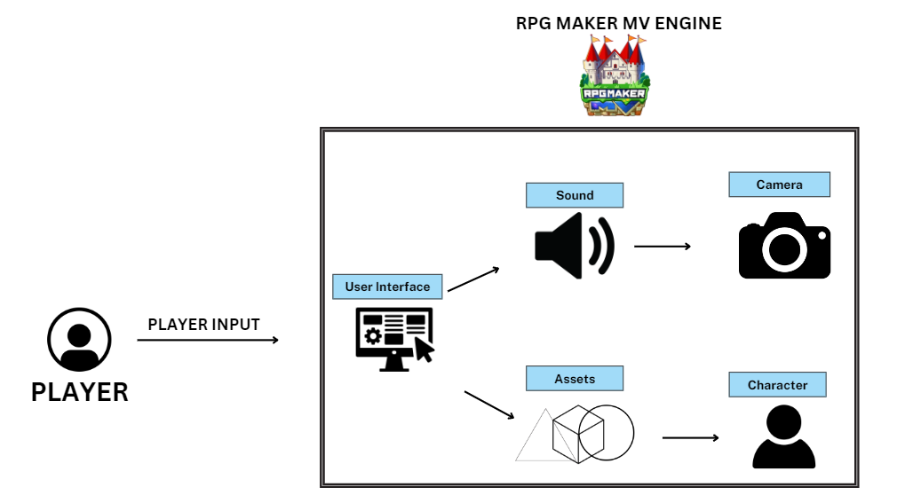

**Figure 2.** Game Architecture of the Proposed Game

For the Development of the 2D Platformer Game, the game's system architecture is composed of several essential components, which are illustrated in Figure 2.

The Diagram of the following components:

1. Player: The user.

2. RPG Maker MV Engine: This game engine will serve as the framework of the project. This will be used to integrate all the assets created in the development phase into the game.

3. User interface: This includes elements like menus and handles animations, transitions, and user input for menu navigation. It gives the player both audio and visual feedback for a more captivating experience.

4. Sound: The audio components of the game, such as the ambient noises, sound effects, and background music, will be managed by the sound manager. The Sound Manager adds to the atmosphere of the game and gives audio feedback by triggering particular sounds in response to player actions and in-game events.

5. Assets: These are the game's interactive features, which include water, rocks, trees, and stores. It handles the detection and handling of object collisions. Furthermore, it monitors these objects' states and adjusts their behavior in response to player interactions.

6. Character: It controls how the player character in the game moves and behaves. This will be in charge of interpreting the player's input and translating it into physics-driven motions and character animations. In particular, this will take care of controlling the different character states, like standing still, moving, and sprinting.

7. Camera: It controls how the player character in the game moves and behaves. This will be in charge of interpreting the player's input and translating it into physics-driven motions and character animations. In particular, this will take care of controlling the different character states, like standing still, moving, sprinting, and swimming. This ensures smooth and responsive camera movement, enhancing gameplay and providing a clear view of the game environment.

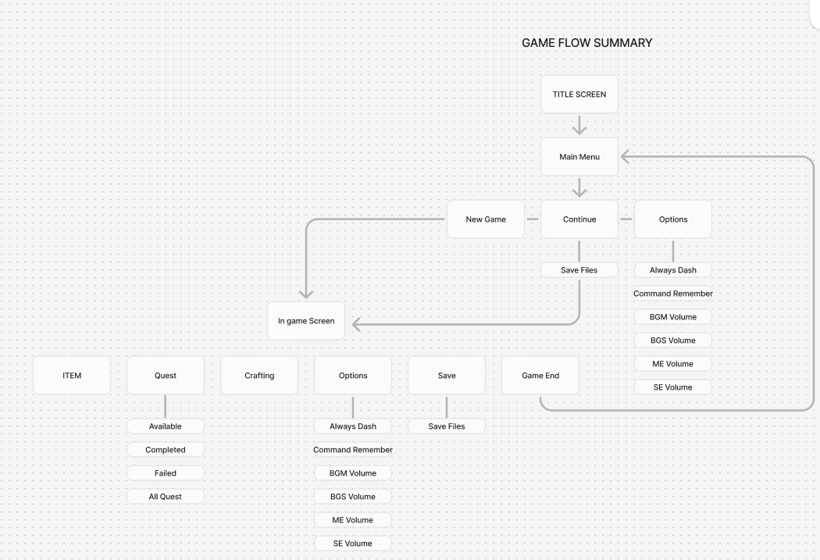

**Figure 3.** Game Flow Summary

Figure 3 shows the game workflow summary. It functions as the game's flow, guiding the player through each menu system and presenting them with viable options that they can customize to their liking. The main menu of the game allows the user to interact with the option settings, navigate the user interface, and save files. Furthermore, it serves as the central hub for all video game system connectivity, corresponding to the appropriate options according to the 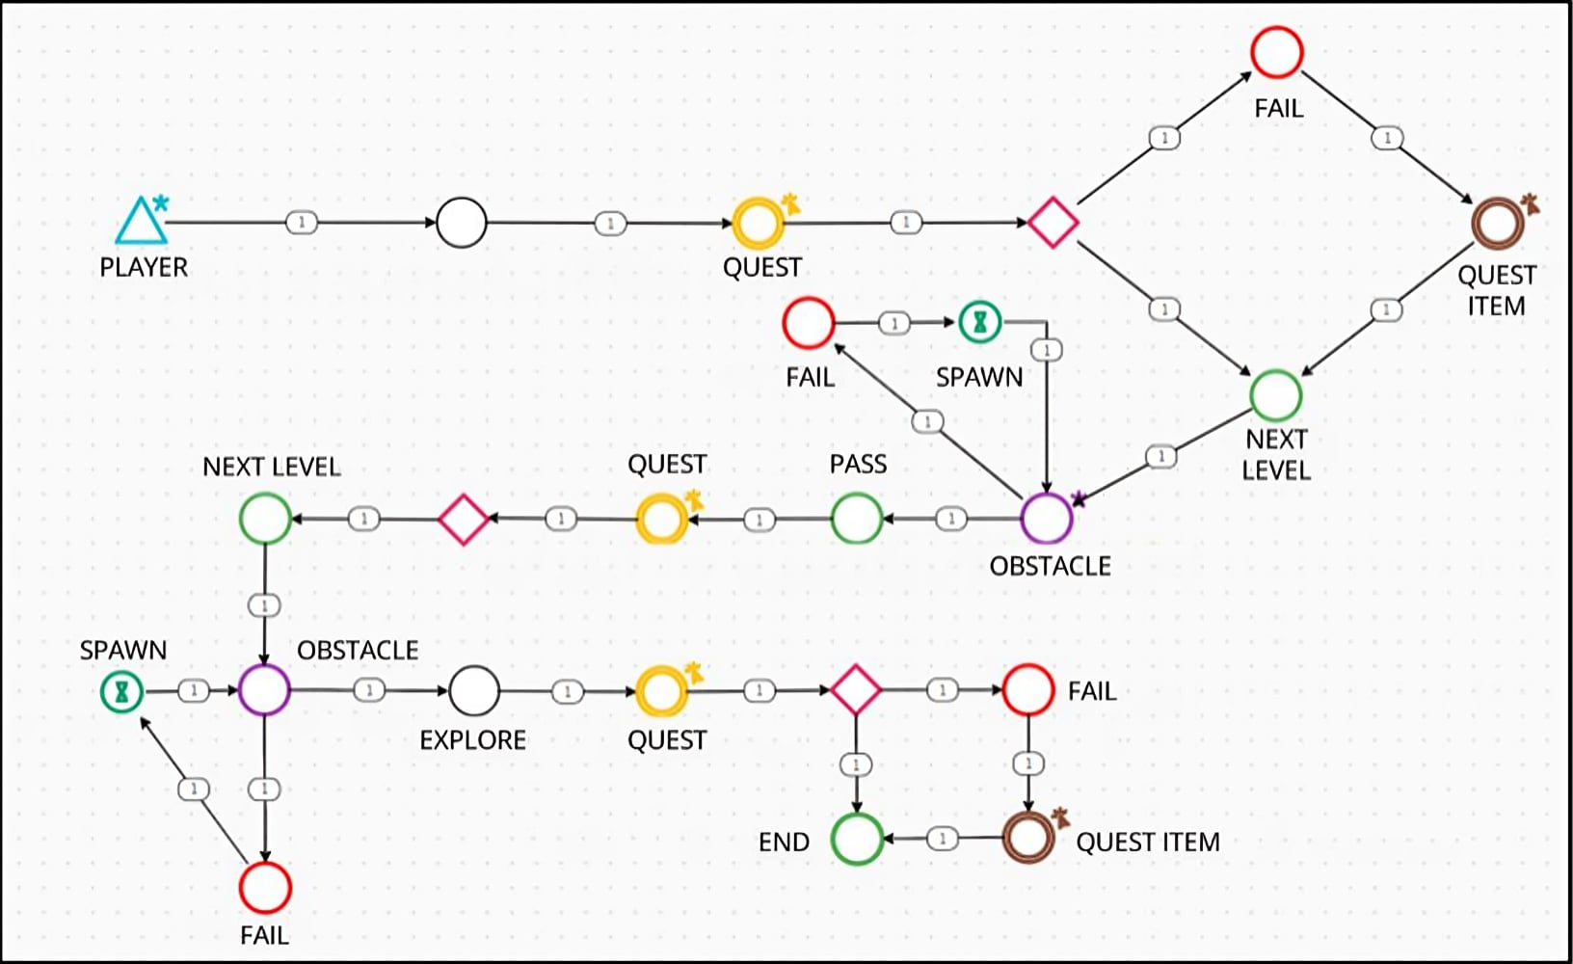user's selections.

**Figure 4.** Gameplay Machination

Figure 4 shows the level-by-level systematic development with quest. The player advances when tasks are completed; failing to do so will restart the quest until completed. In Level 2, challenges are presented, and failing causes one to try again until conquering them. Similar steps are taken in Level 3, where one must overcome another challenge to claim and finish the mission. If he fails, he will be offered another chance until he has completed the quest. The player must complete a certain task, in order to proceed within the game’s main story and to proceed the rest of the levels of the game.

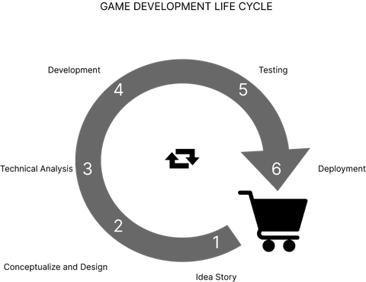

**Figure 5.** Game Development Cycle

Figure 5 shows the study entitled “Gastropolis: A Culinary Introspective of Iloilo Cuisine” the iterative model was used as the game development life cycle approach. By using this method, the researchers combined user feedback with their requirements to make sure the game they were developing fulfilled the study's goals and specifications. Up until the finished product is produced, a cycle of planning, designing, developing, and testing is repeated.

The researchers decided to employ the iterative approach because it allows for flexibility and modifications at any point during the development process. Early identification and resolution of issues could lead to a more polished end product. Additionally, it allows for user involvement and feedback, ensuring that the final product meets the users' needs and expectations.

CHAPTER 4 RESULTS AND CONCLUSIONS

Implementation

The study's implementation phases are displayed in this section, encompassing the game’s pre-production, production, and post-production to the Top-down 2D RPG game using the RPG Maker MV engine in production. Post-production activities focused on refining the game for an immersive player experience. The combination of various inputs, including artistic interpretations and research data, produced captivating audio experiences, accurate depictions, and an engaging story. Through continuous testing and feedback sessions with a variety of people, particularly knowledgeable game developers, game lovers, and gamers, the researchers addressed the technical challenges, refined the gameplay mechanics, and improved the playing experience of the game throughout the development process, from pre-production to post-production.

**Pre-Production**

This phase established the story and graphic framework for the fully immersive game experience. To achieve the first objective of “Gastropolis”, a captivating storyline based on Iloilo the City of Gastronomy, was meticulously crafted, allowing players to unravel its history.

In scriptwriting, the team defined the narrative and dialogues, setting, and storytelling for the game (Figure 6.1). 2D Character designs were accomplished using Photoshop and the game assets were accomplished using Aesprite (Figure 6.2.,6.3.) Concurrently, environmental concepts, enriched by references including stock photos from Google, created a visually immersive game world rooted in the Gastropolis cultural context.(Figure 6.4).

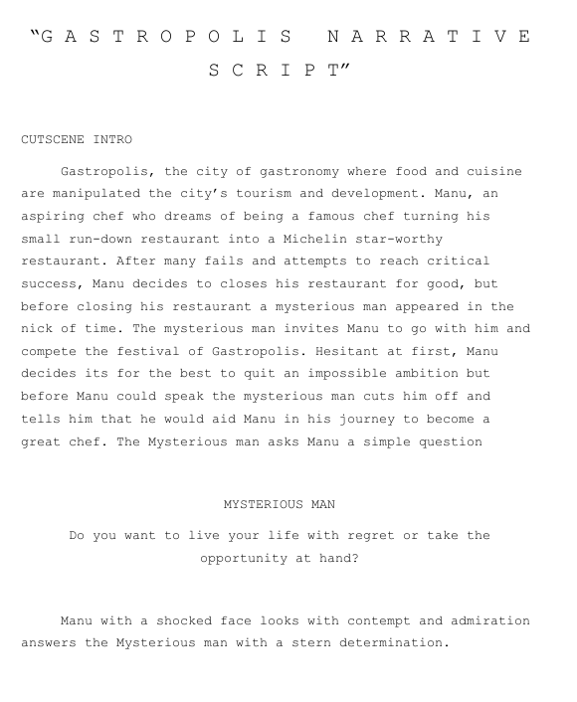

**Figure 6.1.** Game Script

As shown in Figure 6.1, the game's official story consists of narrative, plot, characters, setting, and flow of where the story will go.

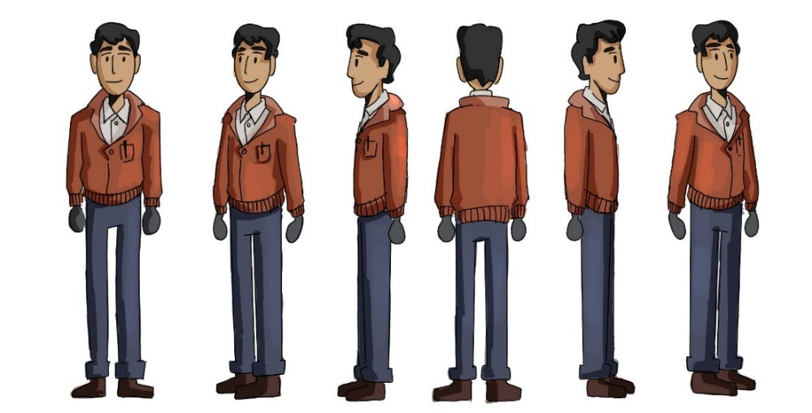

**Figure 6.2.** MC Character Design

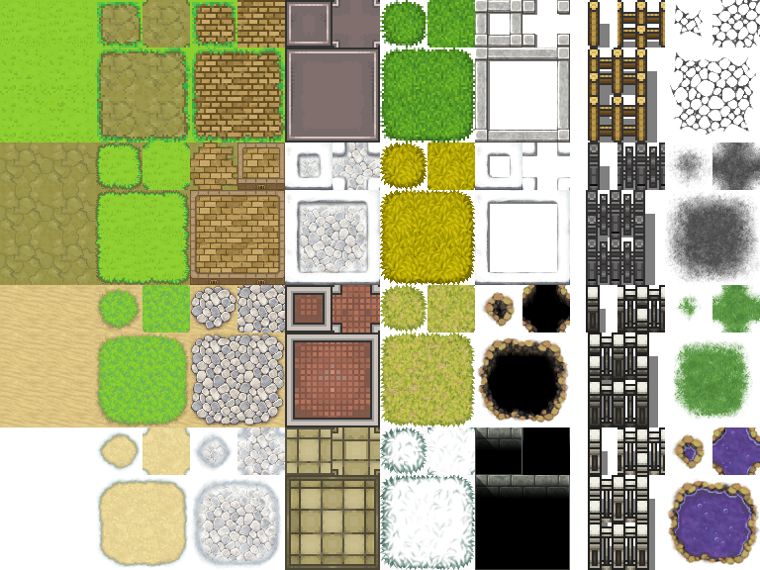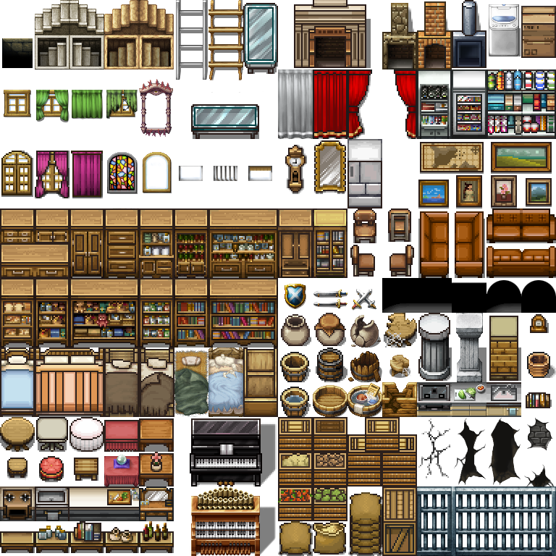

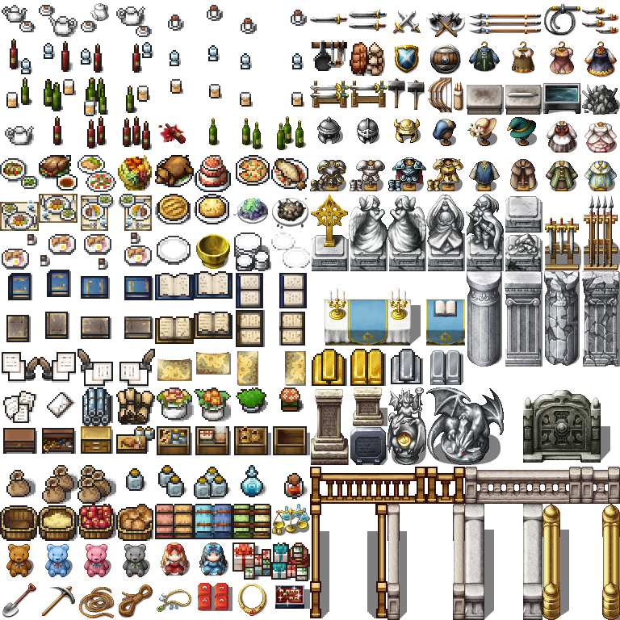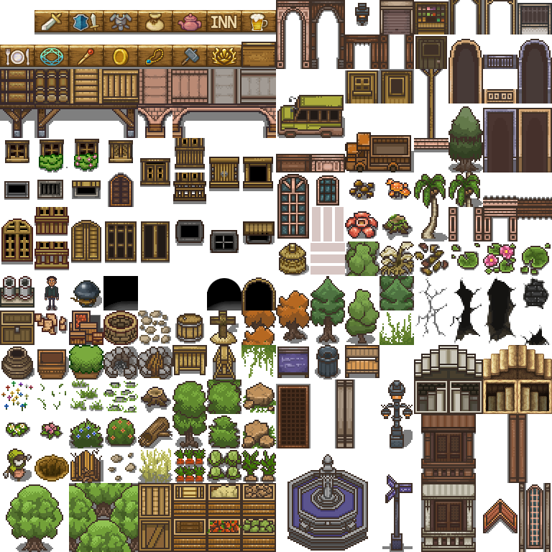

**Figure 6.3.** Assets made using Aesprite

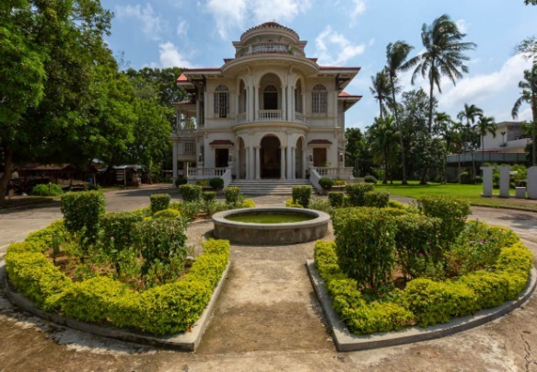

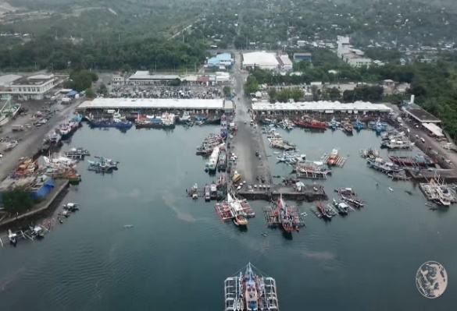

**Figure 6.4** Google stock photos used for map reference

**Production**

At the beginning of this phase, the objectives are to design a three-level game featuring authentic representations of characters, environments, and assets from Iloilo City. Additionally, the game should incorporate two-dimensional pixelated mapping to tell the story of Iloilo City's culture. The envisioned game started to materialize with the creation of 2D characters, including the player and NPCs, using Aesprite (Figure 6.5.). These finely beautiful figures enhanced the immersive gaming experience by dynamically and visually engagingly bringing the narrative and character concepts to life.

Furthermore, the production phase saw the development of 2D environments using Aesprite, providing the game with visually rich and coherent settings (Figure

6.6.)  
 Various software’s were also utilized for soundtrack composition and voice recording; specifically, LMMS

(Figure 6.7.).

Implementing game programming using RPG Maker MV within the game engine marked a significant milestone in the production phase (Figure 6.8.). This scripting language allowed for the integration of various game elements, ensuring smooth interactivity and functionality as players navigated through the City of Gastropolis, for a visual representation, and to provide players with a preview of the game, a 2D game logo was created using Aesprite (Figure 6.9.).

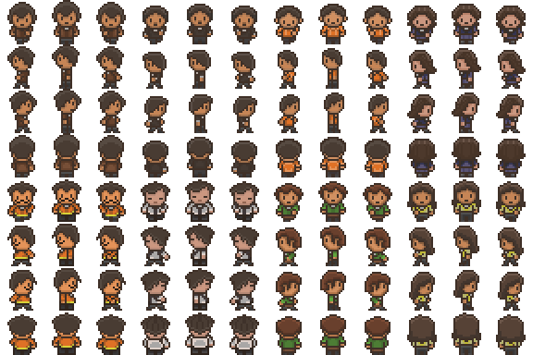

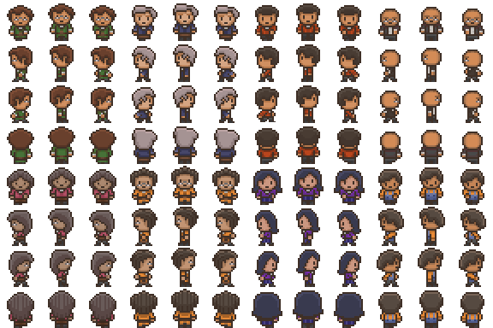

**Figure 6.5** 2D Character Design made using Aesprite

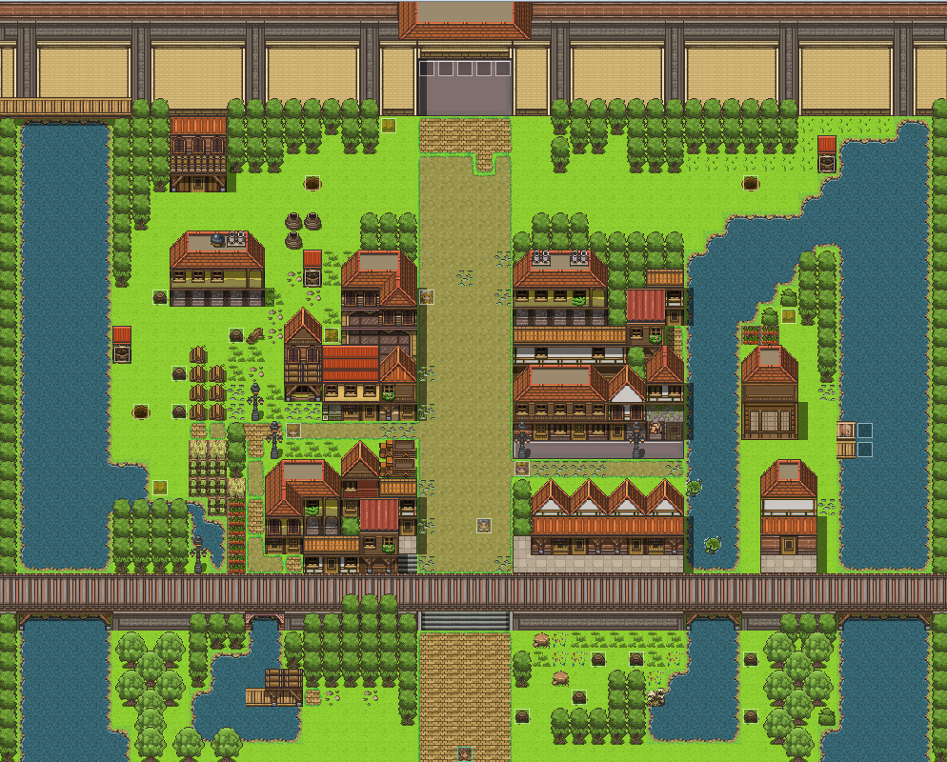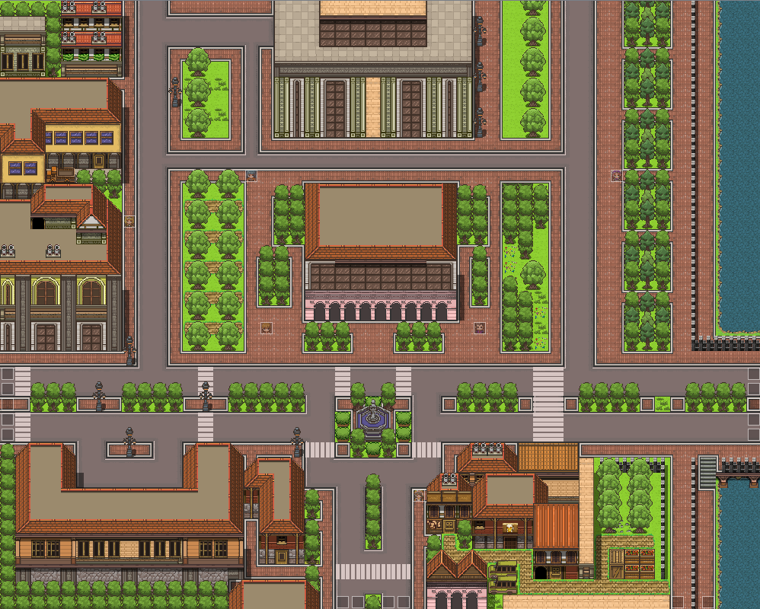

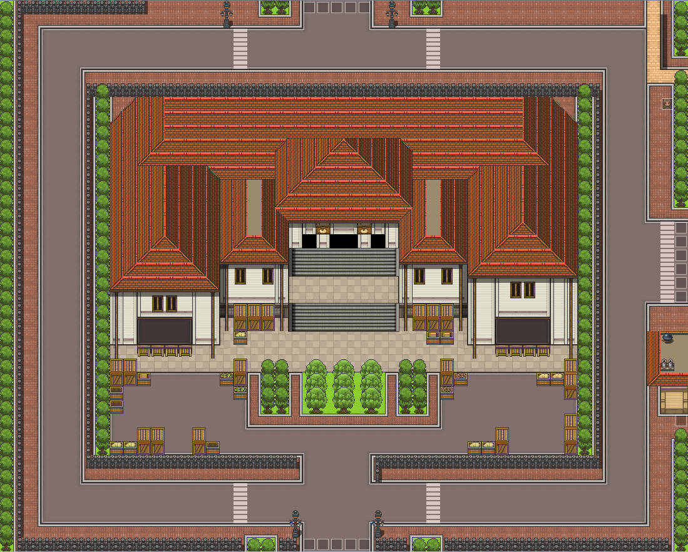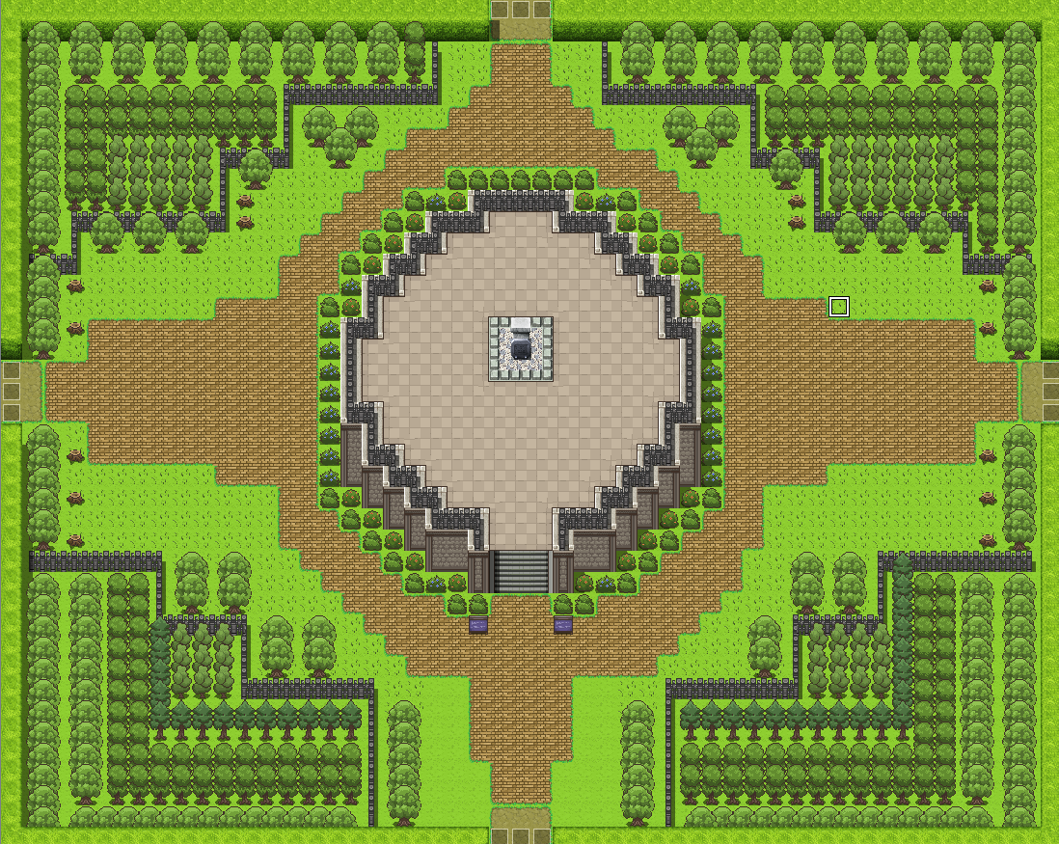

**Figure 6.6.** 2D Map Environment Design made using Aesprite

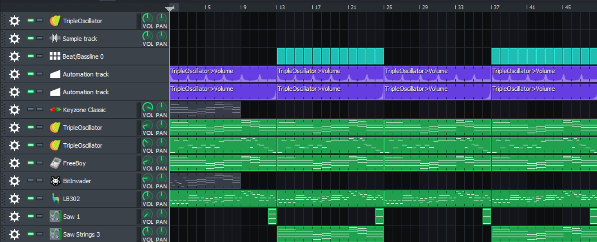

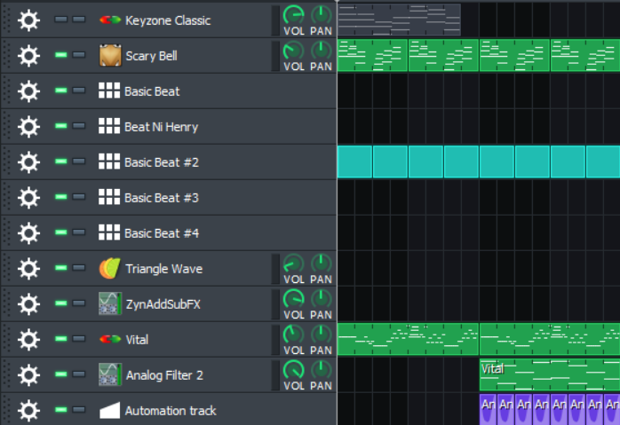

**Figure 6.7.** Soundtrack Composition using LMMS

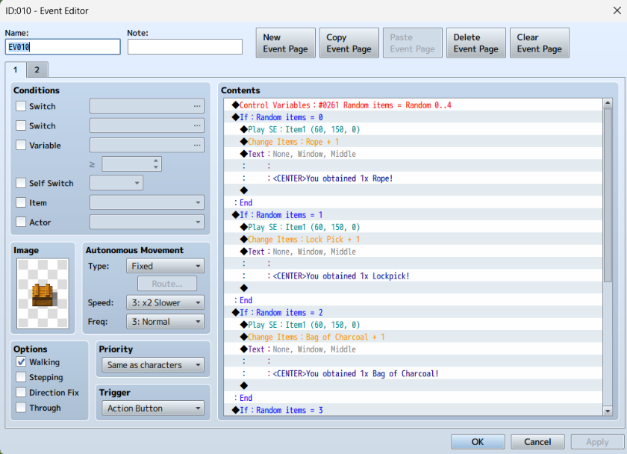

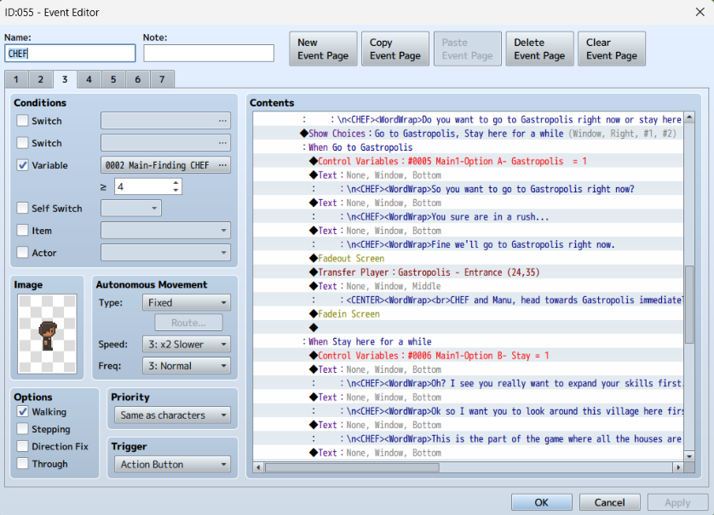

**Figure 6.8.** Game Programming inside RPG Maker MV



**Figure 6.9.** Game Logo using Aseprite and Photoshop

**Post-Production**

The primary objective of the post-production stage was to thoroughly test the game, which was an essential step in finding and fixing any flaws or defects that could affect the gameplay. Throughout this painstaking testing procedure, the game was compared to predetermined specifications to make sure it adhered to expectations. This stage represented a critical turning point, denoting the completion and playability of the game following the intense manufacturing phase.

The post-production phase was a thorough process that focused on improving, polishing, and testing the game before its official launch. The researchers conducted a thorough analysis, exploring different aspects of the game to improve its overall quality. To maximize the gaming experience, is required to resolve any remaining problems, enhance performance, and fine-tune components.

The evaluation's findings not only improved the game but also offered insightful information that further improved its framework.

Post-production was essentially the last stage of creating a game. While we've completed the final stage of development, 'Gastropolis' is still in its alpha phase. While the game itself is complete, with the core gameplay mechanics, map, narrative, and other key elements in place, it is still in alpha, which means that new additional content, gameplay elements, and other quality-of-life features can still be implemented, combining the feedback taken from the alpha test players and the developer's insights.

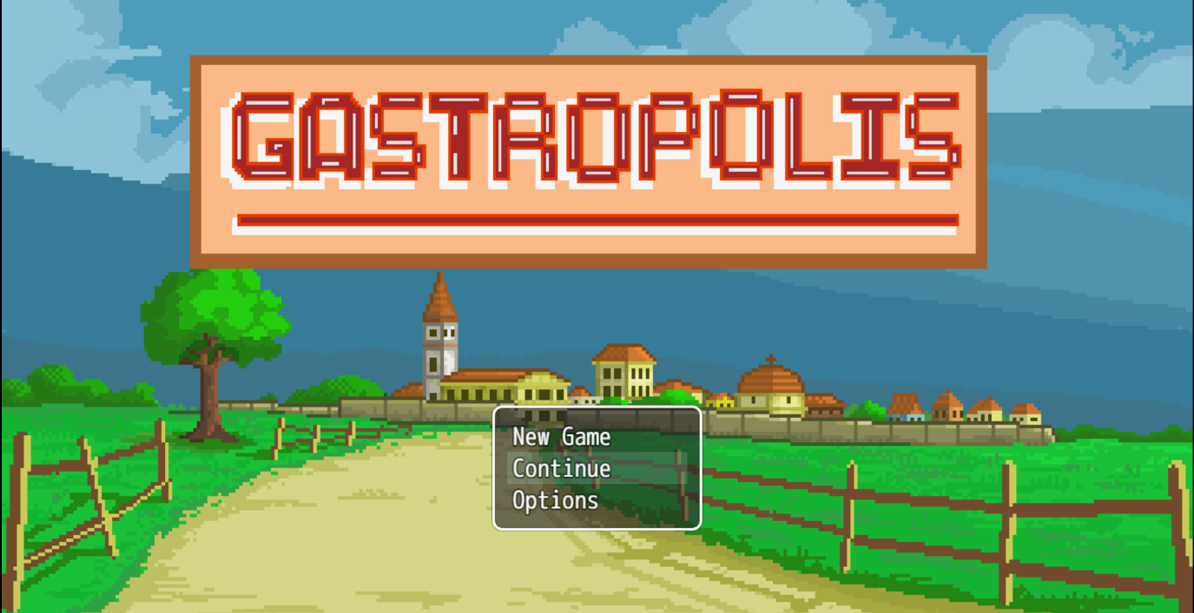

**Figure 7.1.** Main Menu when launching Gastropolis Game

Figure 7.1 shows the game menu UI underwent meticulous design improvements, focusing on visual appeal, navigational clarity, and user-friendly interactions. The figure showcases an intuitive menu layout that seamlessly integrates essential elements, providing players with easy access to various game features and settings.

The game menu's user interface (UI) was carefully redesigned, with an emphasis on clear navigation, aesthetically pleasing elements, and intuitive interactions. The figure's smart menu arrangement elegantly incorporates vital elements, allowing players to easily access different game features and settings.

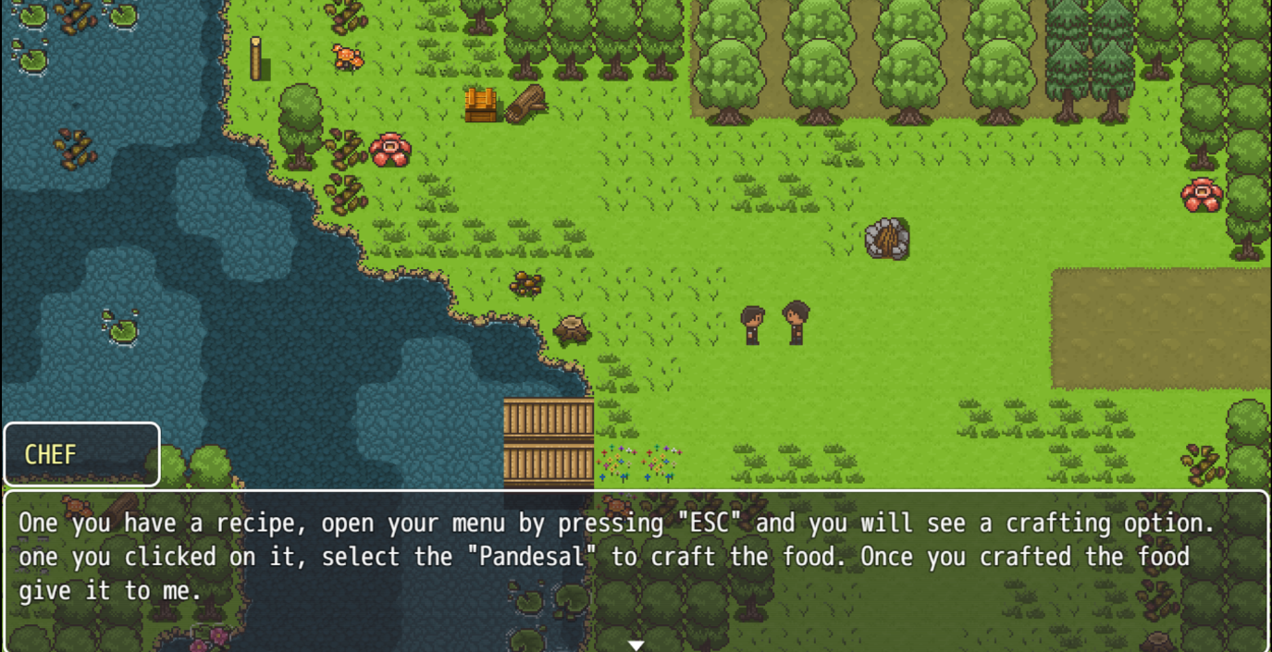

**Figure 7.2.** Interacting with NPC’s

Figure 7.2 shows the conversation with the Quest Giver. Enhancing the in-game dialogue interface was paramount to fostering immersive storytelling. This figure demonstrates the refined dialogue system, featuring visually engaging character interactions, improved readability, and a cohesive design that contributes to the overall narrative flow.

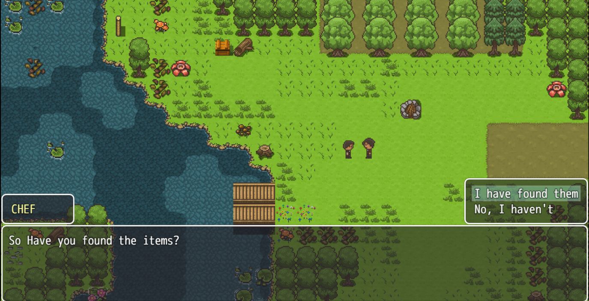

**Figure 7.3.** Player choices and interaction

Figure 7.3 shows the player interaction with quests and objectives; careful consideration was taken in designing the user interface of the quest system. The picture showcases the quest UI, which has been designed to include clear objectives, progress monitoring, and interactive components. These aspects enhance the game experience by seamlessly guiding players through their tasks.

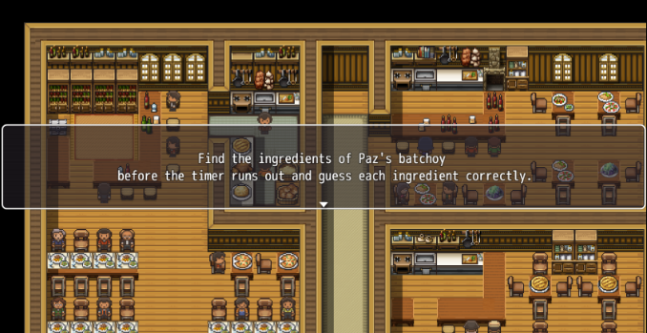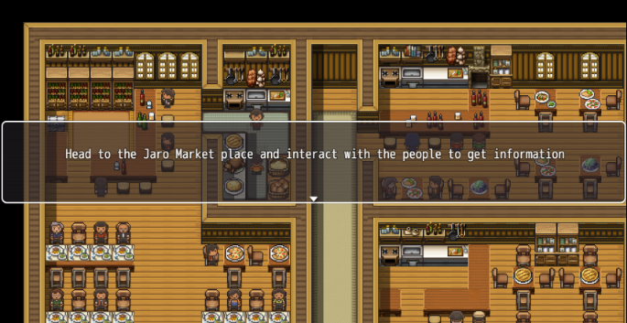

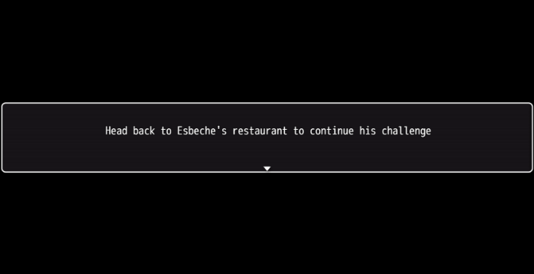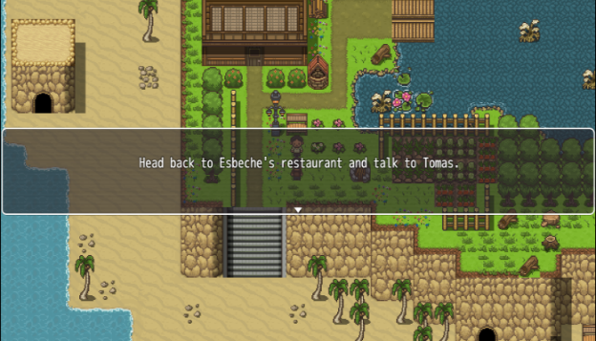

**Figure 7.4** Player task and challenge

Figure 7.4 shows the player encounters specific challenges assigned by different NPCs, and each NPC presents a unique task, appearing in the center of the screen to indicate what must be completed to progress through the game. This approach gives the game a sense of direction, guiding players on what to do next. Successfully solving each task allows the player to advance and unlock new areas of the game. However, failing to complete the task results in a game over.

Results Interpretation and Analysis

The game experience questionnaire evaluation

The study is evaluated using the game experience questionnaire, based on the modular structure [46], and underwent validation by professionals in the game development field.

The questionnaire was used to test the game’s immersion, flow, positive effect, negative effect, difficulties encountered, immersive cultural and food experience, cultural food and storytelling connection, musical and audio resonance, and overall post-game sentiment.

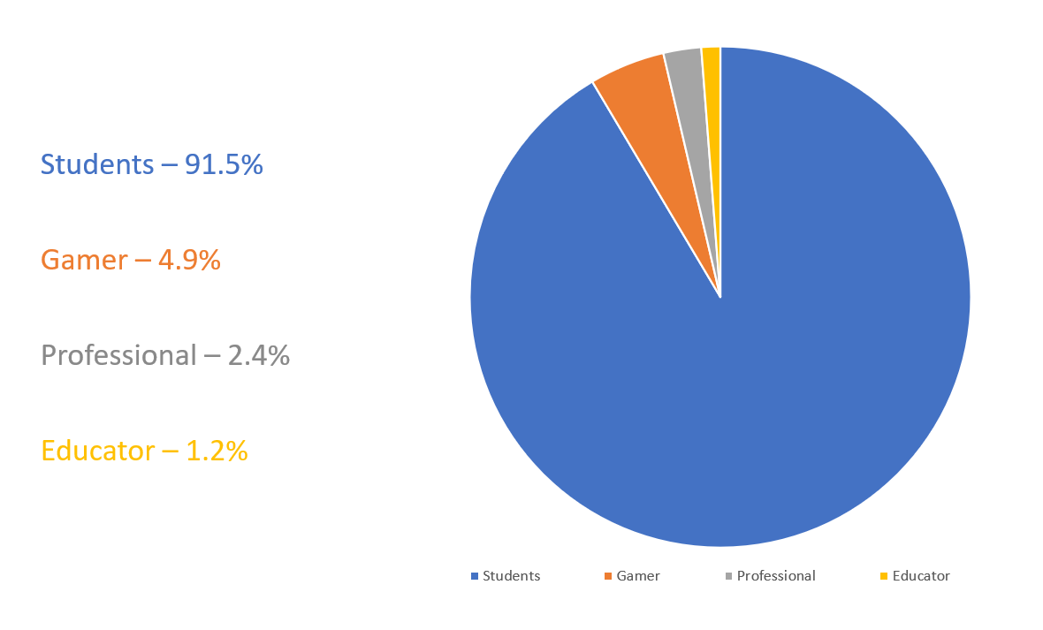

**Figure 8.** Demographic of Respondents

As shown in Figure 8, the respondents were both students and non-students. The researchers aimed to get the response coming from different individuals to truly determine the effectiveness of the game. Table 1 shows the distribution of the respondents.

Table 1. Variety of Respondent's Variation

|  |  |
| --- | --- |
| **Variation** | **Percentage** |
| Students | 91.5 |
| Non-Students | 8.5 |

A total of 82 responses were collected from the evaluation questionnaire. The respondents for this study were the students and older people who are non-students.

Table 2. Age of the Respondents and its Percentage

|  |  |
| --- | --- |
| **Age** | **Percentage** |
| 12 - 20 | 35.4 |
| 21 - 25 | 57.3 |
| 26+ | 7.3 |

From the gathered data, the ages of the respondents were in the range of 12-34 years old, and 91.5% of them were students while the 8.5 were non-students. This methodological diversity ensured a comprehensive evaluation of the game's impact across distinct audience segments, contributing to the depth and richness of this study’s findings.

Table 3. 5-Point Likert Scale scoring range

|  |  |  |
| --- | --- | --- |
| **Interpretation** | **Value** | **Range** |
| Strongly Agree | 5 | 4.45 – 5.00 |
| Moderately Agree | 4 | 3.45 – 4.44 |
| Agree | 3 | 2.45 – 3.44 |
| Disagree | 2 | 1.45 – 2.44 |
| Strongly Disagree | 1 | 0.44 – 1.44 |

Table 3 shows the scoring range. The researchers used a 5-point Likert scale adapted from the Eindhoven University's Game Experience Questionnaire. The Likert West Visayas State University COLLEGE OF INFORMATION AND COMMUNICATIONS TECHNOLOGY La Paz, Iloilo City scale contained five choices: Strongly Disagree (1), Disagree (2), Agree (3), Moderately Agree (4), and Strongly Agree (5), providing a numerical framework for assessing participants' experiences during gameplay.

The gathered data from the evaluation were examined and the mean scores were interpreted using a 5-point Likert scale scoring range.

Table 4. Evaluation of Results

|  |  |  |
| --- | --- | --- |
| **Criteria** | **Mean** | **Interpretation** |
| Flow/Immersion | 3.91 | Moderately Agree |
| Positive effects | 3.87 | Moderately Agree |
| Negative effects | 1.90 | Disagree |
| Difficulties Encountered | 2.65 | Agree |
| Immersive Cultural and Food Experience | 3.76 | Moderately Agree |
| Cultural Food and Storytelling Connection | 3.81 | Moderately Agree |
| Musical and Audio Resonance | 3.36 | Agree |
| Overall Post-Game Sentiment | 3.98 | Moderately Agree |

Table 4 shows that most of the criteria were evaluated as “Moderately Agree” which means, the majority of the results indicated a general positive experience towards the game and its overall experience towards players.

Table 5. Results of Flow / Immersion

|  |  |  |
| --- | --- | --- |
| **Flow / Immersion** | **Mean** | **Interpretation** |
| 1. Do you feel engaged while playing? | 3.95 | Moderately Agree |
| 1. Did the game progress smoothly for you? | 3.87 | Moderately Agree |
| 1. I felt immersed in the game environment. | 3.93 | Moderately Agree |
| 1. The game captured my attention well. | 3.89 | Moderately Agree |
| Overall Mean | 3.91 | Moderately Agree |

Table 5 shows a mean score of 3.91, indicating a "Moderately Agree" immersive experience for participants. This underscores a strong positive response to the game's immersive elements, effectively capturing participants' attention. It also indicates a smooth and engaging experience. This suggests a highly positive response to the progression and control aspects of the game.

Table 6. Results of the Positive Effects

|  |  |  |
| --- | --- | --- |
| **Positive effects** | **Mean** | **Interpretation** |
| 1. Does the game bring joy or happiness to you? | 3.93 | Moderately Agree |
| 1. The game gives a refreshing and comfortable feel while playing? | 3.89 | Moderately Agree |
| 1. Does the playing game increase your appreciation for the people surrounding you? As seen and reflected in the game? | 3.80 | Moderately Agree |
| Overall Mean | 3.87 | Moderately Agree |

Table 6 reveals a total mean score of 3.87 for its positive effects, with an interpretation of "Moderately Agree." This indicates that participants experienced a significant level of joy, happiness, and positive emotions while playing the game and gave satisfaction throughout their gaming experience.

Table 7. Results of Negative Effect

|  |  |  |
| --- | --- | --- |
| **Negative Effect** | **Mean** | **Interpretation** |
| 1. Did you think the game showed Iloilo City and its culture incorrectly, or did it make mistakes or offend you? | 1.92 | Disagree |
| 1. Does playing the game promote stereotypes or inaccurate representations of different culinary cultures? | 1.90 | Disagree |
| 3.The game made me feel frustrated or disappointed. | 1.89 | Disagree |
| Overall Mean | 1.90 | Disagree |

Table 7 reveals a total mean score of 1.90 for the game’s negative effects, interpreted as "Disagree". This suggests that participants experienced minimal negative emotions or frustration during gameplay. The findings indicate a generally positive experience, with only slight instances of disappointment or irritation reported by the participants.

Table 8. Results of Difficulties Encountered

|  |  |  |
| --- | --- | --- |
| **Difficulties Encountered** | **Mean** | **Interpretation** |
| 1. Did the game felt hard and pressured at its missions and objectives? | 2.25 | Disagree |
| 1. Have you felt challenged when encountering the game's puzzles, mechanics, and quick-timed events? | 2.52 | Agree |
| 3.Did the game felt enjoyable that you could explore different areas of the game? | 3.19 | Agree |
| Overall Mean | 2.65 | Agree |

Table 8 illustrates participants' perspectives on the overall Difficulty of the game, with a total mean score of 2.65, interpreted as "Agree". This suggests that the participants found the game to be challenging but felt hard and pressured of its missions and objectives.

Table 9. Results of Immersive Cultural and Food Experience

|  |  |  |
| --- | --- | --- |
| **Immersive Cultural and Food Experience** | **Mean** | **Interpretation** |
| 1. Did your game experience help you connect with the cultural heritage or foods of Gastropolis? | 3.76 | Moderately Agree |
| 1. The game, Gastropolis: A Culinary Introspective of Iloilo Cuisine, increased my experience and awareness of Iloilo cuisine. | 3.75 | Moderately Agree |
| Overall Mean | 3.76 | Moderately Agree |

Table 9 reveals a "Moderately Agree" effective integration of Gastropolis cultural elements with a total mean score of 3.76. Participants reported a strong connection to the cultural narrative, emphasizing specific features or moments that enhanced their engagement.

Table 10. Results of Cultural Food and Storytelling Connection

|  |  |  |
| --- | --- | --- |
| **Cultural Food and Storytelling Connection** | **Mean** | **Interpretation** |
| 1. Digital storytelling was effective in preserving and conveying the essence of Iloilo cuisine and heritage in the game, Gastropolis: A Culinary   Introspective of  Iloilo Cuisine. | 3.81 | Moderately Agree |
| 1. In the game, Gastropolis: A Culinary Introspective of Iloilo Cuisine, the connection between cultural food and storytelling helps convey the history and values of a community. | 3.86 | Moderately Agree |
| 1. There were specific features or moments that strengthened my connection to the cultural narrative. | 3.75 | Moderately Agree |
| Overall Mean | 3.81 | Moderately Agree |

Table 10 highlights the effectiveness of digital storytelling in preserving and conveying the essence of the Gastropolis, with a mean score of 3.81, interpreted as "Moderately Agree”. Participants acknowledged the digital storytelling as highly successful, emphasizing its exceptional ability to capture and convey the core essence of the Gastropolis. Also, participants expressed heightened awareness. of the Gastropolis through the game, fostering curiosity and interest in exploring the represented cultural heritage.

Table 11. Results of Musical and Audio Resonance

|  |  |  |
| --- | --- | --- |
| **Musical and Audio Resonance** | **Mean** | **Interpretation** |
| 1. Specific sounds or music related to the game, Gastropolis: A Culinary Introspective of Iloilo Cuisine, influenced my feelings after playing. | 3.34 | Agree |
| 1. Did the music and audio of the game felt immersive and connected to the game's narrative and world-building? | 3.34 | Agree |
| 3. Did you felt that the game's music and audio was aesthetically pleasing and gave a good mood to the game? | 3.42 | Agree |
| Overall mean | 3.36 | Agree |

Table 11 showcases an "Agree" significant impact of audio elements on participants' mood, with a mean score of 3.36. Notably, specific sounds and music related to the Gastropolis as a 2D pixel game continued to profoundly influence participants' feelings, highlighting the compelling role of audio elements in emotional engagement.

Table 12. Results of Overall Post-Game Sentiment

|  |  |  |
| --- | --- | --- |
| **Overall Post-Game Sentiment** | **Mean** | **Interpretation** |
| 1. The game impacted my interest in Iloilo cuisine or culture. | 4.01 | Moderately Agree |
| 1. The game's mechanics were satisfying to use. | 4.03 | Moderately Agree |
| 3. I felt emotionally connected to the game's story. | 3.78 | Moderately Agree |
| 4. I felt satisfied with the overall gaming experience. | 4.09 | Moderately Agree |
| Overall mean | 3.98 | Moderately Agree |

Table 12 shows a "Moderately Agree" high satisfaction level with the overall gaming experience, with a mean score of 3.98. Participants reported a positive post-game sentiment, indicating the game's success in delivering a highly satisfying and engaging experience.

CHAPTER 5 SUMMARY, CONCLUSIONS, AND RECOMMENDATIONS

Summary of the Proposed Study Design and Implementation

Iloilo's rich culinary tradition has become well-known for its traditional dishes that are deeply rooted in the history and culture of the local region. To guarantee their ongoing appreciation and preservation in a world that is modernizing quickly, these dishes must be further promoted and elevated. Iloilo cuisine, including La Paz batchoy, pancit Molo, and kansi (Sinigang na Bulalo), has great cultural significance due to its ancient recipes passed down through the generations through oral tradition and family practice. The culinary traditions were promoted through programs like culinary festivals, cultural education, and digital storytelling, however, the researchers also came up with a new and unique idea to promote culinary traditions and history through video games. The region's culinary identity can be strengthened on a larger scale, and future generations can be inspired by Iloilo's distinctive flavors and stories if its cuisine is better known.

Within this context, the study, " Gastropolis: A Culinary Introspective of Iloilo Cuisine” finds its purpose. The Culinary of Gastropolis, chosen for its captivating landscapes and enchanting stories, serves as a focal point for exploring the potential of games in preserving intangible cultural heritage. The thesis tackles the more general issue of recording and preserving cultural narratives and further promoting customs. The study aims to explore the possibilities and challenges in employing gaming as a tool for cultural preservation by looking into how a game is developed.

The thesis aimed to close the distance between   
conventional storytelling and modern technology,   
providing information about the convergence of cultural   
Gaming and preservation. The study serves as evidence.   
to games' developing function in the preservation of   
culinary customs, cultural heritage, and providing a   
Blueprint for upcoming initiatives in this ever-evolving field.

To assess the reception of the game, a survey was conducted and consisted 82 respondents including students and individuals who are adults and gamers who are very familiar with games.

Summary of Findings

Respondents' overall impression of "Gastropolis: A Culinary Introspective of Iloilo" is positive. With suggestions highlighting immersive features, cultural relevance and enjoyable experience of the game were considered. Positive emotions can be amazing. While negative experiences are few and far between, respondents found the game's difficulty level to be balanced. This makes for an engaging but manageable challenge.

The main objective to promote an immersive cultural culinary experience was achieved. Respondents attested to the competition's effectiveness in preserving and showcasing Iloilo City's food heritage. The game also strengthened ties with Gastropolis and improved cultural awareness. Sound elements were found to support a positive atmosphere. Further, the study strengthen the visual and storytelling aspects.

The post-game sentiment was overwhelmingly positive. Respondents were satisfied with their experiences. Storytelling leaves a lasting impact. This response shows that Gastropolis has been successful in engaging athletes. It provides a meaningful and culturally rich experience that aligns with the objectives of the study.

Conclusion

In conclusion, this study has successfully achieved the objectives outlined in the development of "Gastropolis: A Culinary Introspective of Iloilo Cuisine Game," a 2D Top-down RPG game created using the RPG Maker MV. The primary focus of this study was to design a gaming experience centered around the culture of Gastropolis, with a broader goal of emphasizing the preservation of tangible and intangible cultural heritage in Iloilo City. Each specific objective articulated in the thesis has been surpassed with careful consideration.

The first objective, creating a captivating storyline rooted in the culture and culinary introspective of Iloilo City, has been made and implemented into the game. The narrative provides players with an immersive journey, allowing them to delve into the culture behind the culinary and experience of the story firsthand. The second objective, centered on the development of a 2D game with three levels, has been achieved through meticulous design. Realistic depictions of characters, environments, and essential assets mentioned in the culture were carefully crafted, striking a balance between research findings and artistic interpretation.

The third objective focused on delivering a high-quality audio experience. By incorporating music and thoughtfully crafted sound effects, the researchers successfully complemented the game's atmosphere, enhancing the overall sensory experience for players.

The fourth objective involved a systematic evaluation using the "Game Experience Questionnaire" adapted from Eindhoven University Technology, Department of Industrial Design and Human-Computer Interaction.

This approach provided valuable insights into the player experience, allowing for refinements and optimizations.

This study acknowledges the potential of games beyond entertainment, emphasizing their effectiveness in preserving and conveying tangible and intangible cultural heritage, and culinary experience. This challenges the conventional notion that games are only for commercial purposes and highlights their broader educational and cultural significance.

Another notable feature of the game is its attention to detail in recreating the environment and atmosphere of Iloilo City, from the old buildings to the streets and famous restaurants. This level of authenticity, not only enhances the player's experience, but also serves to promote tourism and encourage players to visit the real-life location that inspired the game.

Overall, "Gastropolis: A Culinary Introspective of Iloilo Cuisine Game" exemplifies the potential of technology in preserving and promoting cultural heritage. By fusing traditional storytelling with contemporary gaming elements, the game creates a unique and engaging experience that is both entertaining and educational. This innovative approach, not only captivates players, but also deepens their understanding of Iloilo's rich culinary traditions, ensuring that these cultural narratives continue to thrive in the modern world. Through immersive gameplay and meaningful interactions, "Gastropolis" successfully bridges the gap between past and present, highlighting the importance of cultural preservation in an ever-evolving landscape.

Recommendations

The completion of the study, “: A Culinary Introspective of Iloilo Cuisine”, marks a significant success. However, as with many projects, there exist areas that could be enhanced in future iterations of the game. A notable recommendation is the implementation of a save system that allows the user to save the player’s progress in the game without tampering the game files and the ability to name specific save files, a navigation system for the user to navigate around the area of the game and highlighting the objectives and items throughout the map, and providing instructions for the player in the game both in the main menu and in the selective menu of the game.

For future researchers venturing into the realm of creating a role-playing game using RPG Maker MV, it is advisable to understand how to the game engine works, how to create plug-in code’s using Java script, and how to manage in-game events effectively. This strategic investment ensures a more efficient progression in the development process, facilitating a smoother workflow and contributing to the overall success of the project.

References

[1] P. BrainLight, “The Importance of Video Games — Project Brain Light,” *Project Brain Light*, Sep. 15, 2021.[Online]. Available: [https://www.projectbrainlight.org/blog/learn-by- gaming](https://www.projectbrainlight.org/blog/learn-by-gaming).[Accessed Feb. 10, 2024].

[2] アビナッシュ・サラバナン A. S., “Why Video Games are Important and Everyone Should Play Them,” Medium, Jan. 09, 2024. [Online]. Available: <https://medium.com/@asarav/why-video-games-are-important-and-everyone-should-play-them-9925be30722d>.[Accessed Feb. 10, 2024].

[3] J. Rendon, “Iloilo City named UNESCO creative city of gastronomy,” Philstar.com, Nov. 02, 2023. [Online]. Available: <https://www.philstar.com/headlines/2023/11/03/2308524/iloilo-city-named-unesco-creative-city-gastronomy>.[Accessed Feb. 12, 2024].

[4] D. Guardian, “Giving Iloilo City a second look,” *Daily Guardian*, Aug. 24, 2023. [Online]. Available: <https://dailyguardian.com.ph/giving-iloilo-city-a-second-look/>.[Accessed Feb. 12, 2024.]

[5] “The Role of Game Design in Cultural Preservation: Promoting heritage through gaming | MoldStud,” Jan. 22, 2024. [Online].Available <https://moldstud.com/articles/p-the-role-of-game-design-in-cultural-preservation-promoting-heritage-through-gaming>.[Accessed Feb. 15, 2024].

[6] R. Bramble, “Everything You Need To Know Before You Make A 2D Game,” GameMaker, Mar. 05, 2023.[Online].Available <https://gamemaker.io/en/blog/how-to-make-a-2d-game>.[Accessed Feb. 15, 2024].

[7] “Aseprite,” Apr. 12, 2021.[Online] Available: <https://www.computerhope.com/jargon/a/aseprite.htm>.[Accessed Feb. 16, 2024].

[8] R. Games, What Are Assets in Game Design? 2023. [Online]. Available: <https://retrostylegames.com/blog/what-are-assets-in-game-design/#:~:text=Game%20assets%20are%20any%20individual,scripting%20for%20things%20like%20physics>.[Accessed Feb. 19, 2024].

[9] The Editors of Encyclopaedia Britannica, “Cuisine | Definition, Types, & Facts,” Encyclopedia Britannica, Jul. 20, 1998.[Online].Available: <https://www.britannica.com/topic/cuisine>.[Accessed Feb. 22, 2024].

[10] L. A. White, “Culture | Definition, Characteristics, Examples, Types, Tradition, & Facts,” Encyclopedia Britannica, Jul. 26, 1999.[Online].Available <https://www.britannica.com/topic/culture>.[Accessed Feb. 19, 2024].

[11] N. Stefyn, “What is Game Design and How to Become a Game Designer,” cgspectrum, Oct. 15, 2024.[Online].Available: <https://www.cgspectrum.com/blog/what-is-game-design>.[Accessed Feb. 22, 2024].

[12] N. Macedo, “Gameplay: The Essence that Defines a Successful Game,” Aug. 09, 2023.[Online].Available: <https://www.linkedin.com/pulse/gameplay-essence-defines-successful-game-nath%C3%A1lia-macedo/>.[Accessed Feb. 25, 2024].

[13] P. M. Greenfield, “Video games as cultural artifacts,” Journal of Applied Developmental Psychology, vol. 15, no. 1, pp. 3–12, Jan. 1994. doi: 10.1016/0193-3973(94)90003-5.[Accessed Feb. 25, 2024].

[14] D. Dodge, “The Definitive Guide to Video Game Genres and Game Types,” *CodaKid*, May 24, 2024.[Online].Available: <https://codakid.com/video-game-genres/>.[Accessed Mar. 05, 2024].

[15] J. Hegarty, B. Mahony, “Gastronomy: a phenomenon of cultural expressionism and an aesthetic for a living,” ELSEVIER, December 26, 2000.[Online].Available: <https://www.sciencedirect.com/science/article/abs/pii/S0278431900000281>.[Accessed Mar. 06, 2024].

[16] N/A, “The Art of Game Design,” *Google Books*.[Online].Available: <https://books.google.com.ph/books?id=kRMeBQAAQBAJ&redir_esc=y>.[Accessed Mar. 06, 2024].

[17] D. Earl, “LMMS: A Complete Guide to Dance Music Production Beginner’s Guide,” Packt Publishing Ltd. September 2012[Online].Available:<https://books.google.com.ph/books?hl=en&lr=&id=jZM2kq_IK6QC&oi=fnd&pg=PT18&dq=what+is+LMMS+music+software&ots=SsZLALwQDx&sig=z3T62m1QS7ufjwQ3GgmhNDucBp8&redir_esc=y#v=onepage&q=what%20is%20LMMS%20music%20software&f=true>.[Accessed Mar. 09, 2024].

[18] “Game Map,” H5P.[Online].Available: <https://h5p.org/content-types/game-map#:~:text=A%20game%20map%20consists%20of,create%20a%20game-like%20experience>.[Accessed Mar. 09, 2024].

[19] Juegoadmin, “The Ultimate Beginner’s Guide to Game Mechanics,” Juego Studio, Sep. 27, 2024.[Online].Available: <https://www.juegostudio.com/blog/the-ultimate-beginners-guide-to-game-mechanics#:~:text=Game%20mechanics%20are%20the%20rules,resource%20management%20systems%2C%20and%20more>.[Accessed Mar. 09, 2024].

[20] D. Eng, “What are Game Goals and Objectives”, University XP, December 6, 2022.[Online].Available: <https://www.universityxp.com/blog/2022/12/6/what-are-game-goals-and-objectives>.[Accessed Mar. 11, 2024].

[21] Techopedia, “Pixel Art,” Techopedia.com, Jun. 19, 2015.[Online].Available:<https://web.archive.org/web/20220526072849/https://www.techopedia.com/definition/8884/pixel-art>.[Accessed Mar. 11, 2024].

[22] V. Gkogkidis, “PROTOTYPING LEARNING GAMES,” Sep. 12, 2022.[Online].Available:<https://www.linkedin.com/pulse/prototyping-learning-games-vasilis-gkogkidis/>.[Accessed Mar. 12, 2024].

[23] L. Manovich, “Inside Photoshop,” Nov. 01, 2011.[Online].Available: <http://computationalculture.net/inside-photoshop/>.[Accessed Mar. 13, 2024].

[24] S. P. Raikar, “Puzzle | Definition, Origins, Types, & Facts,” Encyclopedia Britannica, Sep. 20, 2022.[Online].Available: <https://www.britannica.com/topic/puzzle>.[Accessed Mar. 15, 2024].

[25] D. Perez “Beginning RPG Maker MV,” Apress Berkeley, CA, June 18, 2016.[Online].Available: <https://link.springer.com/book/10.1007/978-1-4842-1967-6>.[Accessed Mar. 15, 2024].

[26] M. Zaks, “Building a Quest System - HackerNoon.com - Medium,” Medium, Jul. 19, 2018. [Online]. Available: <https://medium.com/hackernoon/building-a-quest-system-cf7f1d3da132>.[Accessed Mar. 17, 2024].

[27] R. Awati, “role-playing game (RPG),” WhatIs, Jul. 14, 2023. [Online]. Available: <https://www.techtarget.com/whatis/definition/role-playing-game-RPG#:~:text=A%20role%2Dplaying%20game%20(RPG)%20is%20a%20game%20in,BattleTech%2C%20and%20Star%20Wars%20Galaxies>.[Accessed Mar. 18, 2024].

[28] U. Technologies, “Unity - Manual:  Tilemap.”[Online]. Available: <https://docs.unity3d.com/2019.1/Documentation/Manual/class-Tilemap.html>.[Accessed Mar. 18, 2024].

[29] C. to C. Gamicus, “Top-down perspective video games,” Codex Gamicus.[Online]. Available: <https://gamicus.fandom.com/wiki/Top-down_perspective_video_games#:~:text=Terminology,eye%20view%20or%20helicopter%20view>.[Accessed Mar. 19, 2024].

[30] Lark Editorial Team, “User Interface (UI),” Jun. 25, 2024. [Online]. Available: <https://www.larksuite.com/en_us/topics/gaming-glossary/user-interface-ui>.[Accessed Mar. 20, 2024].

[31] “What is Video Games | IGI Global.” [Online]. Available: <https://www.igi-global.com/dictionary/video-games/31544#google_vignette>.[Accessed Mar. 22, 2024].

[32] C. Hodent, “The Psychology of Video Games: Are Video Games Good or Bad For Players?,” *Celia Hodent*, May 03, 2021. [Online]. Available: <https://celiahodent.com/the-psychology-of-video-games/>.[Accessed Mar. 22, 2024].

[33] J. Gackenbach, D. Wijeyaratnam, and C. Flockhart, “The Video Gaming Frontier,” *Boundaries of Self and Reality Online*, [Online]. Available: pp. 161–185, 2017, doi: 10.1016/b978-0-12-804157-4.00009-8.[Accessed Mar. 27, 2024].

[34] B. Marklund, H. Engstr[ö](https://link.springer.com/article/10.1007/s40869-019-00085-1#auth-Henrik-Engstr_m-Aff1)m, M. Hellkvist, P. Backlund, “What Empirically Based Research Tells Us About Game Development” Springer Link, September 24, 2019. [Online]. Available: <https://link.springer.com/article/10.1007/s40869-019-00085-1#:~:text=In%20summary%2C%20the%20empirical%20studies,and%20control%20are%20de-emphasized>.[Accessed Mar. 28, 2024].

[35] J. Majewski, “Cultural Heritage in Role-Playing Video Games: A Map of Approaches,” *Furnace Journal*, no.2, 2015.[Online]. Available: https://www.academia.edu/16673904/Cultural_Heritage_in_Role_Playing_Video_Games_A_Map_of_Approaches.[Accessed Apr. 05, 2024].

[36] R. Heinz Prager, “Exploring The Use of Role-playing Games In Education,” *Master of Teaching Research Journal*, no. 2, pp. 1–5, 2019, [Online]. Available:<https://mtrj.library.utoronto.ca/index.php/mtrj/article/view/29606>.[Accessed Apr. 05, 2024].

[37] S. Deterding and J. Zagal, *Role-Playing Game Studies*. Routledge, 2018.[Online]. Available:<http://books.google.ie/books?id=ix9WDwAAQBAJ&printsec=frontcover&dq=9781315637532&hl=&cd=1&source=gbs_api>.[Accessed Apr. 06, 2024].

[38] M. Keo. “Graphical Style in Video Games.”[Online]. Available: <https://core.ac.uk/download/pdf/93082889.pdf> [accessed March 18, 2024].[Accessed Apr. 13, 2024].

[39] D. Lieberman, “What can we learn from playing interactive games?,” in Playing video games, Routledge, 2012, pp. 447–469. [Online]. Available: https://ocw.metu.edu.tr/pluginfile.php/2381/mod_resource/content[1].[Accessed Apr. 16, 2024].

[40] A. Marczewski. “Gamification: A Simple Introduction,” Andrzej Marczewski,2013,[Online]. Available: <https://books.google.com.ph/books?hl=en&lr=&id=IOu9kPjlndYC&oi=fnd&pg=PA3&dq=gamification&ots=kKJu3NdPY_&sig=1lDVMwg5r8FGDhGxVcP5_4ellO4&redir_esc=y#v=onepage&q=gamification&f=false>.[Accessed Apr. 17, 2024].

[41] L. Solinap, “Iloilo City recognized as Unesco Creative City of Gastronomy,” *SunStar Philippines*, SunStar Publishing Inc., Nov. 01, 2023.[Online]. Available: <https://www.sunstar.com.ph/iloilo/iloilo-city-recognized-as-unesco-creative-city-of-gastronomy>.[Accessed Apr. 19, 2024].

[42] J. Rendon, “Iloilo City named UNESCO creative city of gastronomy,” *PhilStar*, The Philippine Star, Nov. 03, 2023.[[Online]. Available: https://www.philstar.com/headlines/2023/11/03/2308524/iloilo-city-named-unesco-creative-city-gastronomy](https://www.philstar.com/headlines/2023/11/03/2308524/iloilo-city-named-unesco-creative-city-gastronomy).[Accessed Apr. 20, 2024].

[43] P. M. Greenfield, “Video games as cultural artifacts,” *Journal of Applied Developmental Psychology*, [Online]. Available: vol. 15, no. 1, pp. 3–12, Jan. 1994, doi: 10.1016/0193-3973(94)90003-5.[Accessed Apr. 21, 2024].

[44] “The Role of Game Design in Cultural Preservation: Promoting heritage through gaming | MoldStud,” Jan. 22, 2024. [Online]. Available: https://moldstud.com/articles/p-the-role-of-game-design-in-cultural-preservation-promoting-heritage-through-gaming#:~:text=Game%20design%20allows%20for%20the,and%20learn%20about%20various%20cultures.[Accessed Apr. 22, 2024].

[45] R. Tamosevicius, “Why Is Game-Based Learning Important?,” eLearning Industry, Nov. 21, 2022. [Online]. Available: <https://elearningindustry.com/why-is-game-based-learning-important>.[Accessed Apr. 24, 2024].

[46] W. A. IJsselsteijn, Y. A. W. De Kort, and K. Poels, “The Game Experience Questionnaire,” *Research Portal Eindhoven University of Technology*, 2013.[Online]. Available: <https://research.tue.nl/en/publications/the-game-experience-questionnaire>.[Accessed Apr. 26, 2024].

Appendices

Appendix A

Letter to the Adviser



Appendix B

Letter to the English Editor



Appendix C

Letter to the Technical Editor



Appendix D

Letter to the Format Editor



Appendix E

Certification for Bookbinding



Appendix G

Source Code

var SRD = SRD || {};

SRD.Credits = SRD.Credits || {};

var Imported = Imported || {};

Imported["SumRndmDde Credits"] = 1.11;

function Scene_SRD_Credits() {

this.initialize.apply(this, arguments);

}

function Window_CreditsDescripton() {

this.initialize.apply(this, arguments);

}

function Window_CreditsCategory() {

this.initialize.apply(this, arguments);

}

function Window_CreditsList() {

this.initialize.apply(this, arguments);

}

(function(_) {

"use strict";

//-----------------------------------------------------------------------------

// SRD.Requirements

//-----------------------------------------------------------------------------

/*_.alertNeedGameUpgrade = function() {

alert("The 'SRD_GameUpgrade' plugin is required for using the 'SRD_CreditsPlugin' plugin.");

if(confirm("Do you want to open the download page to 'SRD_GameUpgrade'?")) {

window.open('http://sumrndm.site/game-upgrade/');

}

};

if(!Imported["SumRndmDde Game Upgrade"]) {

_.alertNeedGameUpgrade();

return;

}*/

//-----------------------------------------------------------------------------

// SRD.Credits

//-----------------------------------------------------------------------------

var params = PluginManager.parameters('SRD_CreditsPlugin');

if(params['File Location']) {

alert("Please update the parameters for 'SRD_CreditsPlugin'!");

return;

}

_.data = SRD.parse(params['Credit Data'], true);

_.location = String(params['File Location']);

_.useTitle = String(params['Add to Title?']).trim().toLowerCase() === 'true';

_.titleName = String(params['Command Name']);

_.descWindow = String(params['Use Desc. Window']).trim().toLowerCase() === 'true';

_.creditWidth = parseInt(params['Credit Window Width']);

_.fontSize = parseInt(params['Desc. Text Size']);

_.rows = parseInt(params['Category Rows']);

_.columns = parseInt(params['Category Columns']);

_.align = String(params['Text Alignment']);

_.categories = [];

_.lists = {};

_.fileInfo = '';

_.setup = function() {

for(let i = 0; i < _.data.length; i++) {

const data = _.data[i];

const category = data['Name'];

const credits = data['Credits'];

_.categories.push(category);

_.lists[category] = [];

for(let j = 0; j < credits.length; j++) {

const credit = credits[j];

_.lists[category][j] = {};

if(credit['Name']) {

_.lists[category][j].name = credit['Name'];

}

if(credit['URL']) {

_.lists[category][j].link = credit['URL'];

}

if(credit['Description']) {

_.lists[category][j].desc = credit['Description'];

}

}

}

};

_.setup();

//-----------------------------------------------------------------------------

// Game_Interpreter

Appendix H

Disclaimer

This software project and its corresponding documentation entitled “: A Culinary Introspective of Iloilo Cuisine” is submitted to the College of Information and Communications Technology, West Visayas State University, in partial fulfillment of the requirements for the degree, Bachelor of Science in Entertainment and Multimedia Computing. It is the product of our own work, except where indicated text.

We hereby grant the College of Information and Communications Technology permission to freely use, publish in local or international journal/conferences, reproduce, or distribute publicly the paper and electronic copies of this software project and its corresponding documentation in whole or in part, provided that we are acknowledged.

Nicole Anne D. Corral

Rizdy L. Huyatid

Henry R. Nopueto

Christian Jay O. Rentillo

Kenshin S. Supeña

JUNE 2025